Pari GP

Potrzebne funkcje:

Podłoga: floor(x)

Moduł: Mod(x,y) moduł z x/y zapisywany do x

Suma: sum(i=1,4,i) , 1. Arg to start, 2. To zakończenie, 3. To funkcja. Nie potrzeba iteratora.

Tablica: myArray = vector(5, i, i+4); wektory w GP są w 1-bazowe, a nie 0-bazowe.

Funkcje: f(x)=x+1

chinese(x,y) gives the following output. If x = Mod(a, m) and y = Mod(b, n),then the program returns z such that z ≡ a mod m and z ≡ b mod n. Thus if x = 3 mod 5 and y = 6 mod 7,then the output is 13 mod 35. Even if the moduli are not relatively prime, GP will attempt to find a solution,and will give an error message if no solution exists. If there are more than two simultaneous congruences,they can be handled by a workaround. If z = Mod(c, p),we can let w = chinese(x, y) and then compute chinese(z,w). A more systematic and general method will be given in the section on linear algebra.

matsolvemod(A,m,y) generalizes the Chinese remainder theorem. A is a matrix with integer entries, m is a column vector of positive integer moduli,and y is a column vector with components in Z. The output is a “small” integer solution to j aijxj ≡ yi mod mi.

Uzyskiwanie reszt liczby X=1530, z bazu modułów (3,5,7,11,13,17) = (0,0,4,1,9,0)

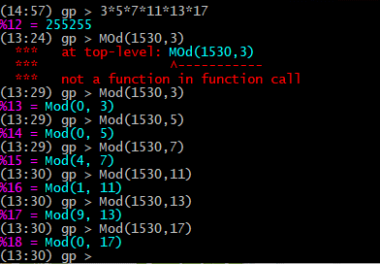

M = iloczyn baz modułu

N = ilość elementów bazy